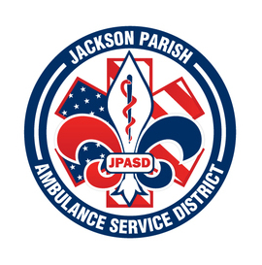
JACKSON PARISH AMBULANCE SERVICE DISTRICT
115 Watts Street
Jonesboro, LA 71251
Office: (318)-259-2877 Fax: (318)-259-2099
jacksonparishambulance@jpasd.com
Aaron Johnson BOARD MEMBERS
EMS Director Allen Lindsay, Chairman
Paula Parkerson , MD Joe Vail, Vice-Chairman
Medical Director Conchita Doyle
Alma Williams
*Vacant*
Notice Posted: Tuesday January 11, 2022 @ 3:45 PM

NOTICE OF PUBLIC MEETING
A public meeting will be held as follows:
DATE: January 13, 2022
TIME: 12:00 PM
PLACE OF MEETING: Jackson Parish Ambulance Service District
115 Watts Street, Jonesboro, LA 71251
Public Meeting AGENDA
1. Call to Order
2. Roll Call
3. Invocation
4. Pledge of Allegiance
5. Recognition of Guests/Public Comments
6. Approval of Minutes from December 2021
7. Approval of Financials and payment of bills December 2021
8. EMS Director’s Report
9. Old Business
A) Rescind Motion-Piggyback off Bossier Parish EMS Cardiac Monitor Bid in the November 2021 Board Meeting
10. New Business
A) Public Bid to purchase Patient Monitor and Defibrillator
B) Training Center Construction Change Order
C) Resignation of Board Member George Wyatt
11. Adjournment
Reminder: Next Meeting: February 10, 2022 @ 12 Noon
In accordance with the Americans with Disabilities Act, if you need special assistance, please contact Aaron Johnson, EMS Director at 318-259-2891 describing the assistance that is necessary. Due to the Covid-19 virus visitors are asked to not present to the meeting with fever, cough, diarrhea, or general weakness. Masks will be provided for visitors.

