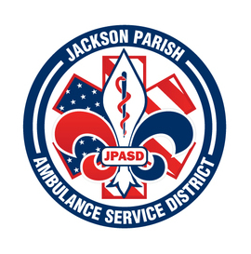
JACKSON PARISH AMBULANCE SERVICE DISTRICT
115 Watts Street
Jonesboro, LA 71251
Office: (318)-259-2877 Fax: (318)-259-2099
jacksonparishambulance@jpasd.com
Aaron Johnson BOARD MEMBERS
EMS Director Allen Lindsay, Chairman
Paula Parkerson , MD Joe Vail, Vice-Chairman
Medical Director Conchita Doyle
Alma Williams
Deidre Hollis
Notice Posted: Tuesday April 12, 2022 @ 12:00 PM

NOTICE OF PUBLIC MEETING
CANCELLATION

A public meeting will be held as follows:
DATE: April 14, 2022
TIME: 12:00 PM
PLACE OF MEETING: Jackson Parish Ambulance Service District
115 Watts Street, Jonesboro, LA 71251

Reminder: Next Meeting: May 12, 2022 @ 12 Noon
In accordance with the Americans with Disabilities Act, if you need special assistance, please contact Aaron Johnson, EMS Director at 318-259-2891 describing the assistance that is necessary. Due to the Covid-19 virus visitors are asked to not present to the meeting with fever, cough, diarrhea, or general weakness. Masks will be provided for visitors.

