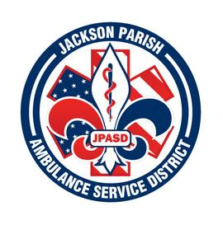
Jackson Parish Ambulance Service District
115 Watts Street
Jonesboro, LA 71251
Office: (318)-259-2877 Fax: (318)-259-2099
jacksonparishambulance@jpasd.com
Aaron K. Johnson, Jr. Paula Parkerson,MD
EMS Director Medical Director
Governing Board: Joe Vail, Allen Lindsay, Alma Williams, Conchita Doyle, Deidre Hollis

Meeting Minutes for Regular Scheduled Board Meeting: Thursday, April 11, 2024@ 12:00 noon

Present: Allen Lindsay, Joe Vail, Conchita Doyle, Alma Williams, Amber Swanner, Aaron Johnson, and Jeff Carpenter.

Absent: Deidre Hollis

Guests: Vickie Vail and Jimmy Horn

Meeting was called to order by Allen Lindsay. Roll call by Aaron Johnson: Present: Allen Lindsay, Joe Vail, Alma Williams, and Conchita Doyle. Absent Deidre Hollis. Guest present Vickie Vail and Jimmy Horn. No comments. Invocation led by Alma Williams. Pledge of Allegiance led by Conchita Doyle. Motion made by Joe Vail and seconded by Conchita Doyle to accept Meeting Minutes March 14th 2024 meeting. All in favor motion carried. Motion made by Conchita Doyle and seconded by Joe Vail to approve and accept the financials and pay bills for March 2024. All in favor motion carried. Director’s report given by Aaron Johnson. Director’s report includes maintenance report, April schedule, March safety training meeting, SAMHSA Grant 6-month report, A-EMT and EMT class, NAEMT training center, SAMHSA grant 2024, Legislation, Upcoming meetings. Motion made by Joe Vail and seconded by Alma Williams to accept the Director’s report. All in favor motion carried. No Old Business. No New Business. Motion made by Conchita Doyle and seconded by Joe Vail to adjourn meeting. All in favor motion carried.

Next Regular Board Meeting will be held:
Thursday, May 9, 2024 @ 12:00 noon
Thursday, June 13, 2024 @ 12:00 noon Aaron Johnson /Secretary-Treasurer
@ JPASD – 115 Watts Street – Jonesboro, LA Unofficial Minutes

