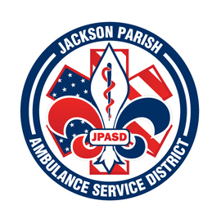
JACKSON PARISH AMBULANCE SERVICE DISTRICT
115 Watts Street
Jonesboro, LA 71251
Office: (318)-259-2877 Fax: (318)-259-2099
jacksonparishambulance@jpasd.com
Aaron Johnson BOARD MEMBERS
EMS Director [ ] Newspaper Allen Lindsay, Chairman
Paula Parkerson , MD [ ] Minutes Conchita Doyle, Vice-Chairman
Medical Director Joe Vail
Alma Williams
Deidre Hollis
Notice Posted: Tuesday, September 10, 2024 @ 1:00 pm

NOTICE OF PUBLIC MEETING
A public meeting will be held as follows:
DATE: September 12, 2024
TIME: 12:00 PM
PLACE OF MEETING: Jackson Parish Ambulance Service District
115 Watts Street, Jonesboro, LA 71251
Public Meeting AGENDA
1. Call to Order
2. Roll Call
3. Invocation
4. Pledge of Allegiance
5. Recognition of Guests/Public Comments
6. Approval of Minutes from August 8, 2024
7. Approval of Financials and payment of bills August 2024
8. EMS Director’s Report
9. Old Business
10. New Business
A) Adopt the 2024 Millage Rate.
B) Surplus Stryker Stretcher SN:070840586 sold at public auction
11. Adjournment
Reminder: Next Meeting: October 10, 2024 @ 12 Noon
In accordance with the Americans with Disabilities Act, if you need special assistance, please contact Aaron Johnson, EMS Director at 318-259-2891 describing the assistance that is necessary. Due to the Covid-19 virus visitors are asked to not present to the meeting with fever, cough, diarrhea, or general weakness. Masks will be provided for visitors.

