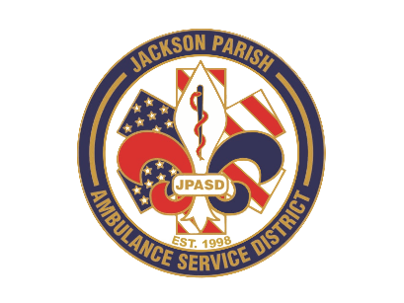
Aaron K. Johnson, Jr - EMS Director

Paula Parkerson, MD - Medical Director

Governing Board
Allen Lindsay, Conchita Doyle, Joe Vail, Alma Williams, Deidre Hollis
Jackson Parish Ambulance Service District
115 Watts Street
Jonesboro, LA 71251
Office: (318) 259-2877
Fax: (318) 259-2099

jacksonparishambulance@jpasd.com

Notice Posted: Tuesday, September 9, 2025 @ 12 noon

NOTICE OF PUBLIC MEETING
A public meeting will be held as follows:
DATE: September 11, 2025
TIME: 12:00 PM
PLACE OF MEETING: Jackson Parish Ambulance Service District
115 Watts Street, Jonesboro, LA 71251

MEETING CANCELLED

Reminder: Next Meeting: October 9, 2025 @ 12 Noon
In accordance with the Americans with Disabilities Act, if you need special assistance, please contact Aaron Johnson, EMS Director at 318-259-2891 describing the assistance that is necessary. Due to the Covid-19 virus visitors are asked to not present to the meeting with fever, cough, diarrhea, or general weakness. Masks will be provided for visitors.

{ } Newspaper
{ } Minutes

