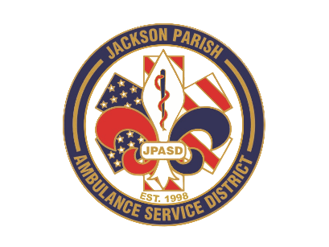
Aaron K. Johnson, Jr - EMS Director

Paula Parkerson, MD - Medical Director

Governing Board
Allen Lindsay, Conchita Doyle, Joe Vail, Alma Williams, Deidre Hollis
Jackson Parish Ambulance Service District
115 Watts Street
Jonesboro, LA 71251
Office: (318) 259-2877
Fax: (318) 259-2099

jacksonparishambulance@jpasd.com

Meeting Minutes for Regular Scheduled Board Meeting: Thursday, October 9, 2025@ 12:00 noon

Present:, Joe Vail, Deidre Hollis, Conchita Doyle, Alma Williams, Aaron Johnson, Amber Swanner and JoLynn Smith.

Absent: Allen Lindsay

Guests: Vickie Vail, Sarah Diffy, Nick Kliebert, and Chrisitan Foster

Meeting was called to order by Conchita Doyle. Roll call by Aaron Johnson: Present: Conchita Doyle, Deidre Hollis, and Joe Vail. Absent Alma Williams and Allen Lindsay. Guest present were Vickie Vail, Sarah Diffy, Nick Kliebert, and Christian Foster. No comments. Invocation led by Conchita Doyle. Pledge of Allegiance led by Deidre Hollis. Alma Williams enters meeting at 12:14pm. Motion made by Joe Vail and seconded by Deidre Hollis to accept Meeting Minutes August 14 and cancelled meeting on September 11. All in favor motion carried. Motion made by Joe Vail and seconded by Alma Williams to approve and accept the financials and pay bills for August and September 2025. All in favor motion carried. Director’s report given by Aaron Johnson. Director’s report includes maintenance report, October schedule, August and September Safety training meeting, Training center buzz, employee update, building update, BEMS inspection delayed, UPL IGT, Grants applied, Mutual Aid agreements, Insurance claim, Medicare billing, Upcoming meetings. Motion made by Joe Vail and seconded by Deidre Hollis to accept the Director’s report. All in favor motion carried. Old Business: None. New business: A. Surplus for public auction (govdeals.com) 2018 G4500 Ambulance VIN#00152. Motion made by Deidre Hollis and seconded by Joe Vail to post surplus ambulance with minimum 30k reserve. All in favor motion carried. B. Accept the 2024 Annual Financial Report by TCBT Accounting firm of no findings, Motion made by Deidre Hollis and seconded by Joe Vail to Accept 2024 Financial Audit. All in favor motion carried. C. Proposal of the 2026 Financial Budget. Motion made by Deidre Hollis and seconded by Joe Vail to propose 2026 financial budget as presented. All in favor motion carried. Motion made by Joe Vail seconded by Deidre Hollis to adjourn meeting. All in favor motion carried.

Next Regular Board Meeting will be held:
Thursday, November 13, 2025 @ 12:00 noon
Thursday, December 11, 2025 @ 12:00 noon Aaron Johnson /Secretary-Treasurer
@ JPASD – 115 Watts Street – Jonesboro, LA Unofficial Minutes

