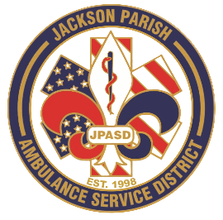
Aaron K. Johnson, Jr - EMS Director

Paula Parkerson, MD - Medical Director

Governing Board
Allen Lindsay, Conchita Doyle, Joe Vail, Alma Williams, Deidre Hollis
Jackson Parish Ambulance Service District
115 Watts Street
Jonesboro, LA 71251
Office: (318) 259-2877
Fax: (318) 259-2099

jacksonparishambulance@jpasd.com

Notice Posted: Tuesday, August 11, 2026 @ 2:00pm

NOTICE OF PUBLIC MEETING
A public meeting will be held as follows:
DATE: August 13, 2026
TIME: 12:00 PM
PLACE OF MEETING: Jackson Parish Ambulance Service District
115 Watts Street, Jonesboro, LA 71251
Public Meeting AGENDA
1. Call to Order
2. Roll Call
3. Invocation
4. Pledge of Allegiance
5. Recognition of Guests/Public Comments
6. Approval of Minutes from June 11, 2026 with July 9, 2026 being cancelled
7. Approval of Financials and payment of bills for June and July 2026
8. EMS Director’s Report
9. Old Business
10. New Business
A) Adopt the 2026 Tax Millage Rate
B) Resolution to apply for grant funding
C) Surplus and Auction- Phone System, Monitors, IV pumps, and CPAPs on GovDeals
D) Approve the Adjusted Pay Scale and Benefit Package
E) Accept the 2025 Financial Audit Report
11. Adjournment
Reminder: Next Meeting: August 13, 2026 @ 12 Noon
In accordance with the Americans with Disabilities Act, if you need special assistance, please contact Aaron Johnson, EMS Director at 318-259-2891 describing the assistance that is necessary. Due to the safety of all visitors, please do not present to the meeting with fever, cough, diarrhea, or general weakness. Masks will be provided for visitors upon request.

{ } Newspaper
{ } Minutes

