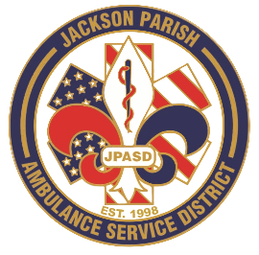
Aaron K. Johnson, Jr - EMS Director

Paula Parkerson, MD - Medical Director

Governing Board
Allen Lindsay, Conchita Doyle, Joe Vail, Alma Williams, Deidre Hollis
Jackson Parish Ambulance Service District
115 Watts Street
Jonesboro, LA 71251
Office: (318) 259-2877
Fax: (318) 259-2099

jacksonparishambulance@jpasd.com

Notice Posted: Tuesday, September 8, 2026 @ 7:00pm

NOTICE OF PUBLIC MEETING
A public meeting will be held as follows:
DATE: September 10, 2026
TIME: 12:00 PM
PLACE OF MEETING: Jackson Parish Ambulance Service District
115 Watts Street, Jonesboro, LA 71251
Public Meeting AGENDA
1. Call to Order
2. Roll Call
3. Invocation
4. Pledge of Allegiance
5. Recognition of Guests/Public Comments
6. Approval of Minutes from August 13, 2026
7. Approval of Financials and payment of bills for August 2026
8. EMS Director’s Report
9. Old Business
10. New Business
A) Board Resolution for Signature Authority
B) Consider proposed Service Rates for Adoption
11. Adjournment
Reminder: Next Meeting: October 8, 2026 @ 12 Noon
In accordance with the Americans with Disabilities Act, if you need special assistance, please contact Aaron Johnson, EMS Director at 318-259-2891 describing the assistance that is necessary. Due to the safety of all visitors, please do not present to the meeting with fever, cough, diarrhea, or general weakness. Masks will be provided for visitors upon request.

{ } Newspaper
{ } Minutes

